PDPB-ID Compliance for Log360
Strengthen data protection and meet PDPB-ID compliance with Log360.
Region: Indonesia | Type: Data Privacy | Category: Compliance | Pricing: Free

Overview
The PDPB-ID compliance extension in Log360 helps organizations meet Indonesia's Personal Data Protection Law (Law No. 27 of 2022), a comprehensive data protection law establishing rights for data subjects and obligations for controllers and processors across all sectors in Indonesia by providing centralized log management, access control auditing, data breach detection, and compliance event tracking. The platform supports PDPB-ID requirements for lawful and transparent processing, data subject rights with 72-hour response, security and confidentiality measures, data protection impact assessment support, Data Protection Officer oversight, cross-border transfer safeguards, and breach notification obligations.
For Lawful and Transparent Data Processing, Log360 tracks user activity, policy changes, and directory configurations to verify processing operations comply with stated purposes and remain within authorized processing scope. To address Data Subject Rights — Access, Rectification and Restriction, the platform monitors user account management, Entra ID changes, and database account modifications to trace authorization workflows for timely data subject request fulfillment. The extension also supports Security, Confidentiality and Technical Safeguards by providing capabilities that monitors failed logons, MFA enforcement, file integrity events, threat detection, and firewall activity to enforce technical safeguards mandated by Indonesian law.

Key Features
- Data Protection Impact Assessment Support: Log360 provides event log analysis, process tracking, computer auditing, and policy reports to document processing flows, risk indicators, and control effectiveness for DPIA requirements.
- Data Protection Officer Appointment and Oversight: Log360 tracks role assignments, Entra ID user management, GPO modifications, and OU changes to support DPO oversight of data protection policies and compliance governance.
- Cross-Border Data Transfer Safeguards: Log360 monitors AWS infrastructure, cloud IAM permissions, Salesforce activity, and cloud authentication to verify adequate protection for international data transfers.
- Breach Detection, Incident Response and Notification: Log360 provides threat detection, anti-malware monitoring, network attack alerts, and firewall threat reports to identify data breaches and meet Indonesian PDPL notification obligations.



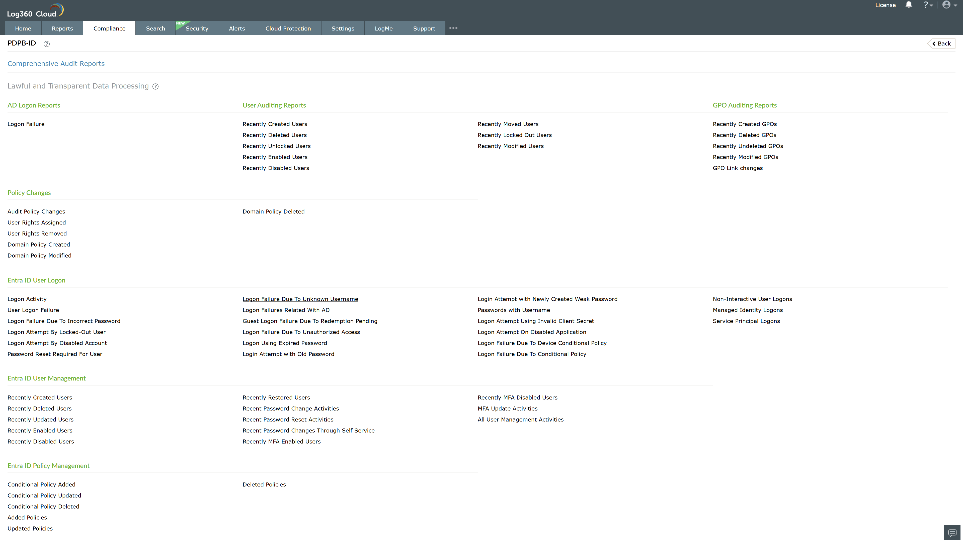
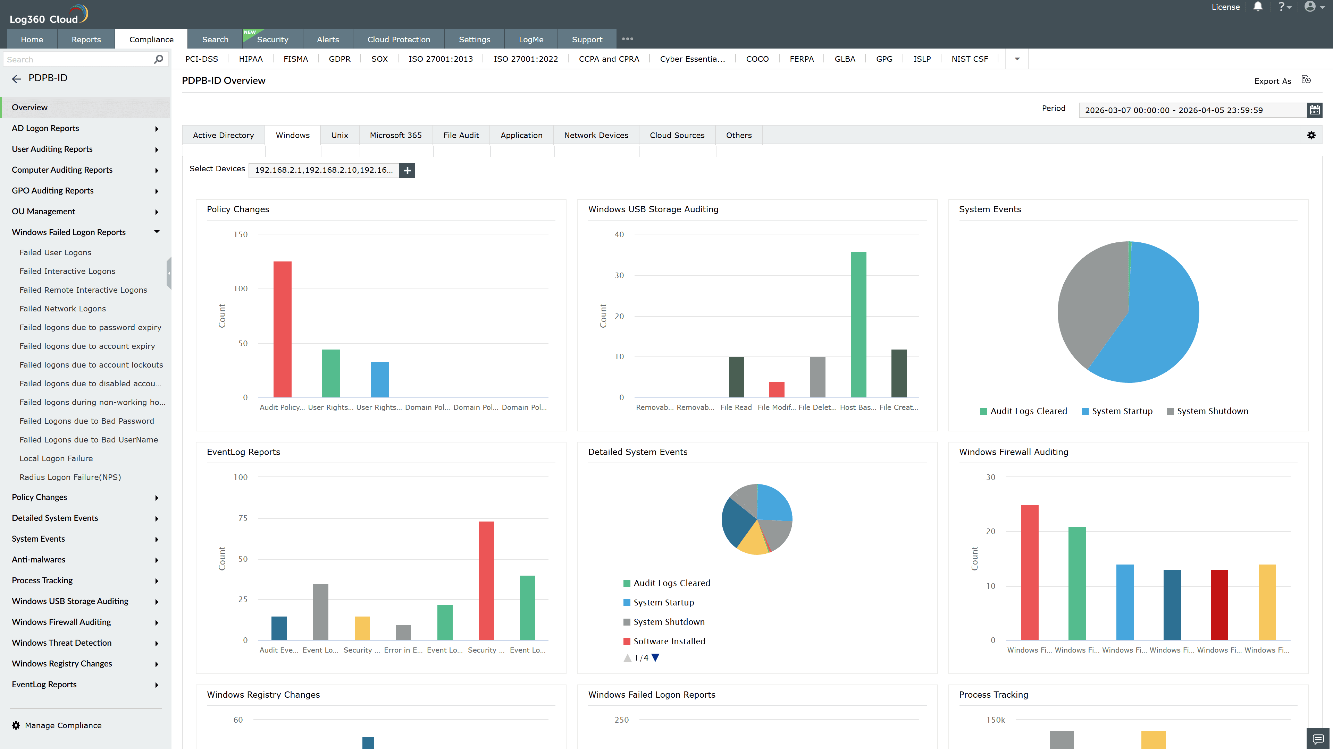
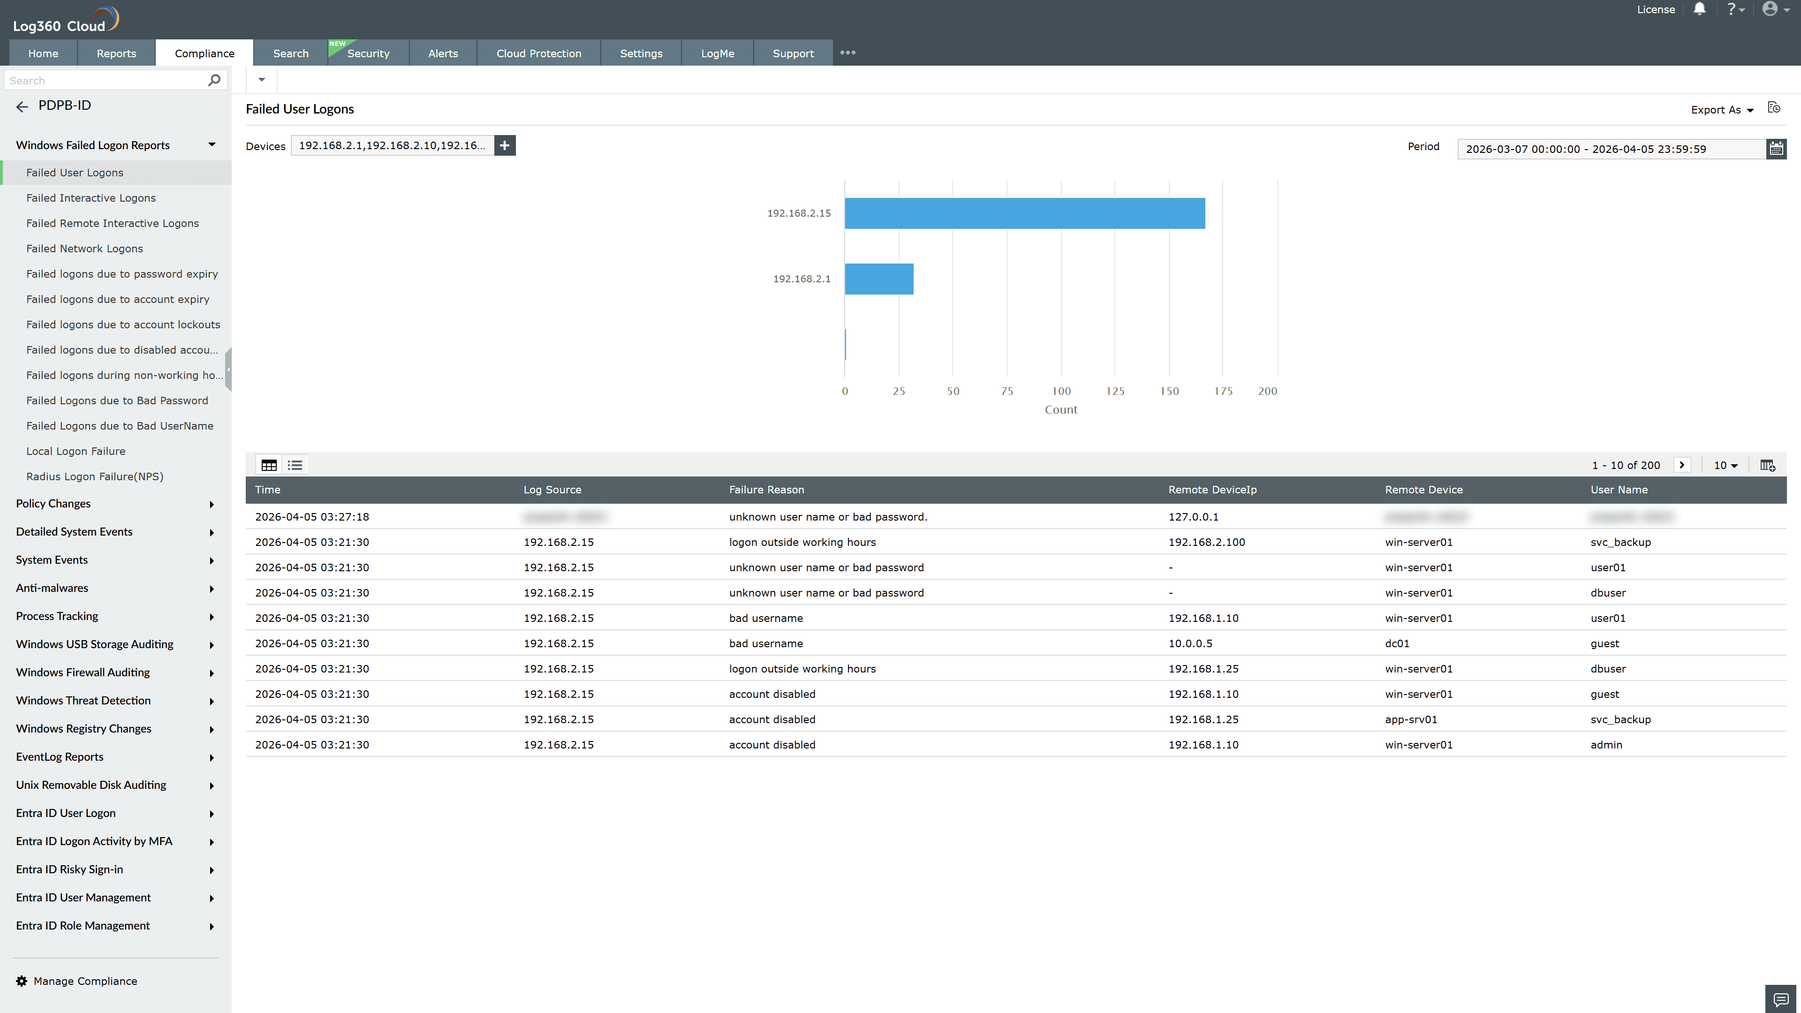
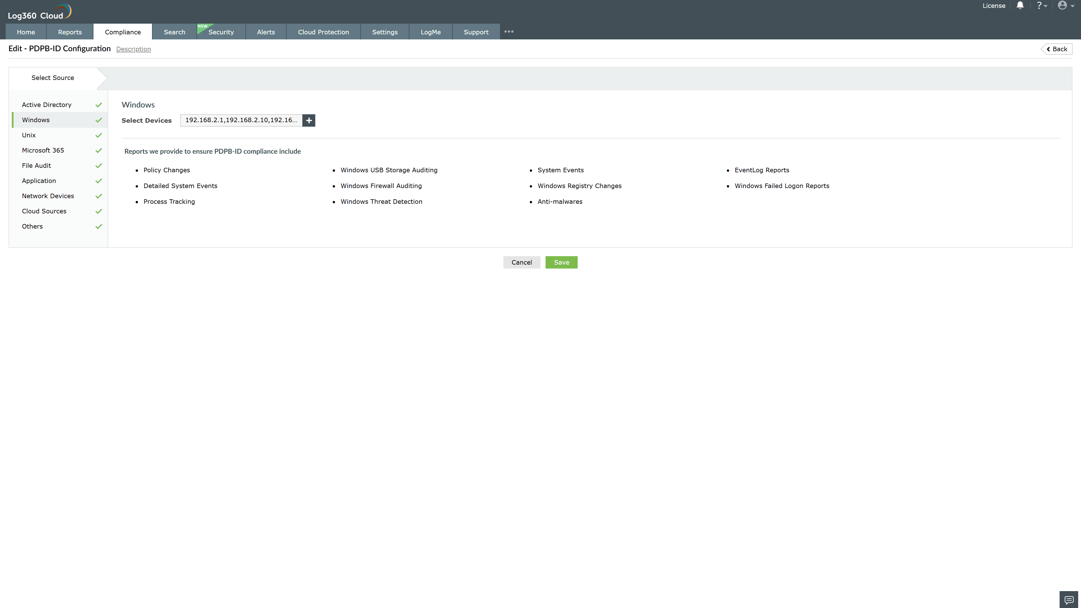
Valid Submission : Yes
Supported Editions : Free, Basic, Standard, Professional, MSSP
Help Document : https://www.manageengine.com/log-management/help/integrations/compliance-extensions.html
Help Video : Not provided
Tags : Log360, Compliance, Privacy monitoring, Data privacy, Regulatory compliance
Supported DCs : US, IN, JP, CA, AU, UK and EU
Privacy Policy:
Terms of Service:
Release Notes:
Predefined reports for the PDPB-ID.

